
Name: | Niraj Patil
Date: | 11/06/2025

Internship Task 2:
import requests
from bs4 import BeautifulSoup

url = "https://books.toscrape.com/"

# Send a GET request
response = requests.get(url)

# Parsing HTML content with BeautifulSoup
soup = BeautifulSoup(response.text, 'html.parser')

# Finding all book containers
books = soup.find_all('article', class_='product_pod')

# Loop through and extract title and price
for book in books:
title = book.h3.a['title']
price = book.find('p', class_='price_color').text
print(f"{title} - {price}")

Screenshot:
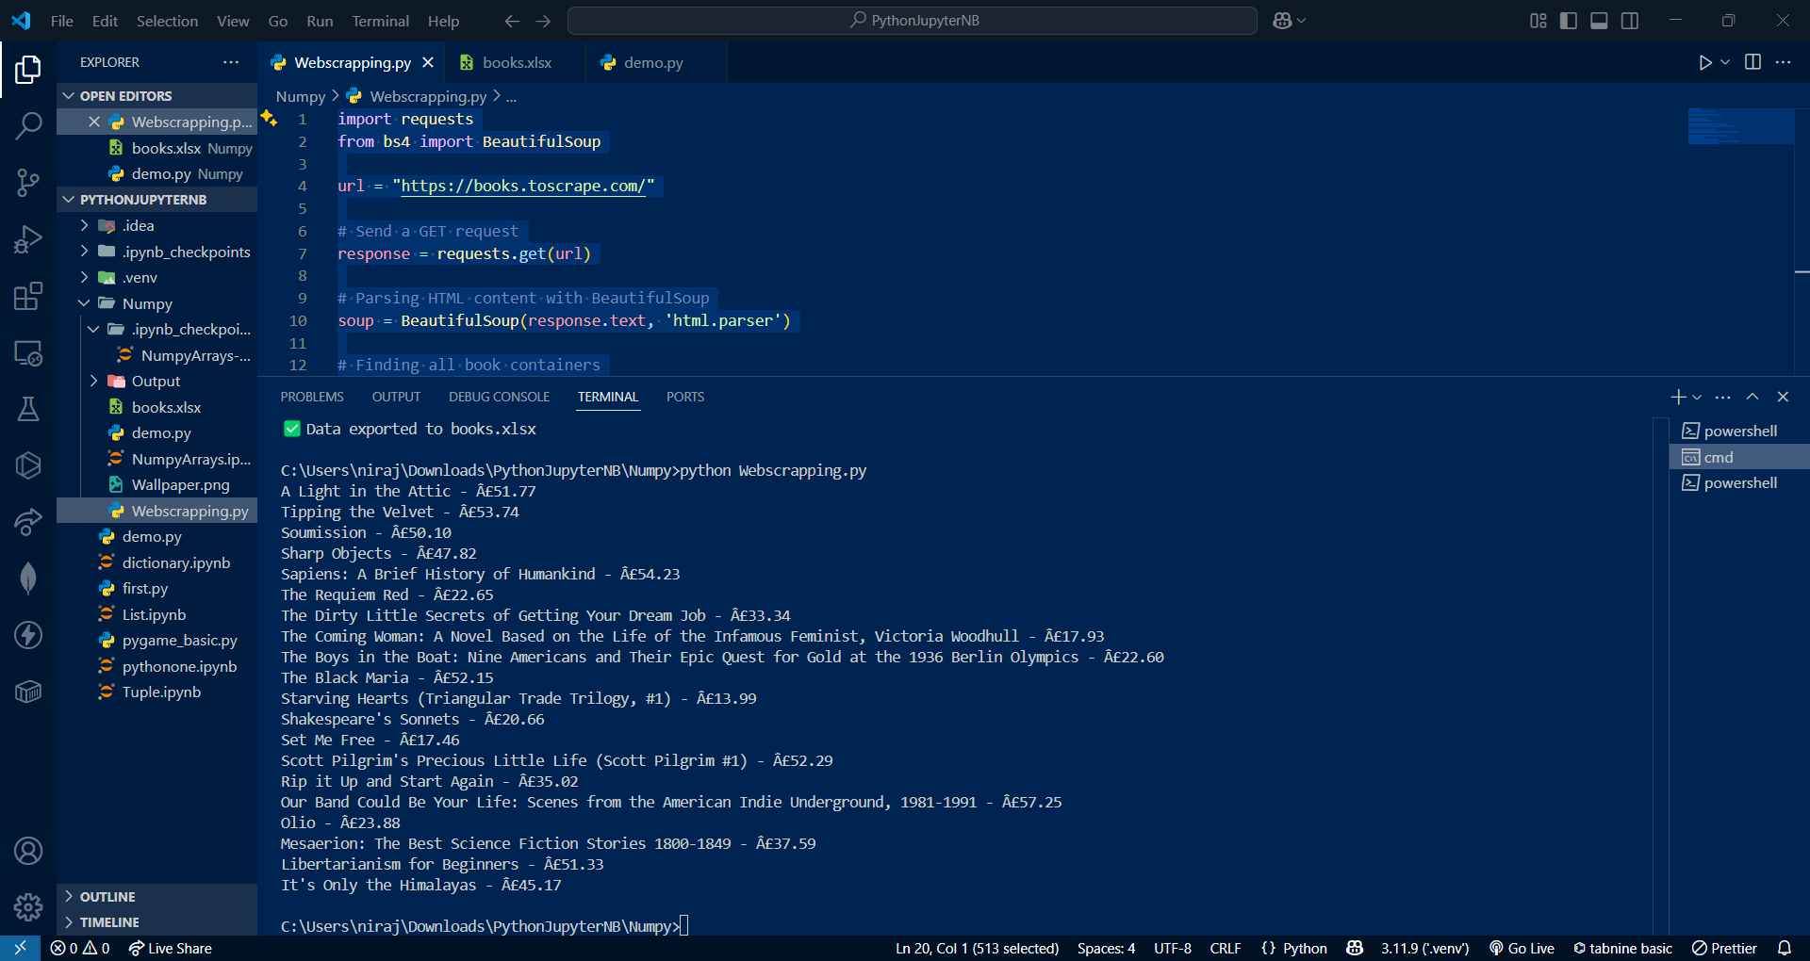

2.
import requests
from bs4 import BeautifulSoup
import pandas as pd

# Target URL
url = "https://books.toscrape.com/"
response = requests.get(url)

# Check for successful request
if response.status_code == 200:
soup = BeautifulSoup(response.text, 'html.parser')
books = soup.find_all('article', class_='product_pod')

# Prepare list of dictionaries
data = []
for book in books:
title = book.h3.a['title']
price = book.find('p', class_='price_color').text
data.append({'Title': title, 'Price': price})

# Convert to DataFrame
df = pd.DataFrame(data)

# Export to Excel
df.to_excel('books.xlsx', index=False)
print(" Data exported to books.xlsx")
else:
print(" Failed to retrieve data")

Screenshot:
